HARNESSING BIOENERGY: ANAEROBIC DIGESTION OF AGRICULTURAL FEEDSTOCK’S FOR BIOGAS EXTRACTION

Arvind Pratap Singh Rathore
Faculty of Electrical & Mechanical Engineering, College of Military Engineering, Pune, Maharashtra, India.
DOI: https://doi.org/10.5281/zenodo.17243034
Abstract
The growing demand for sustainable energy solutions has led to increased interest in biogas production from agricultural feed stocks through anaerobic digestion (AD). India, being an agrarian economy, generates a vast amount of agricultural waste, which presents a significant opportunity for renewable energy generation. This paper comprehensively examines the anaerobic digestion process, highlighting its technological advancements, feedstock availability, production potential, and economic feasibility in India. The paper elaborates on the four-stage process of AD, including hydrolysis, acidogenesis, acetogenesis, and methanogens. Detailing the required infrastructural setups and retention periods for efficient gas yield. A comparative analysis of various agricultural feedstock’s, such as rice husks, wheat straw, and sugarcane bagasse, is conducted based on their calorific values and biodegradability. The research also explores advancements in AD technologies, including high-solid anaerobic digestion (HSAD), two-stage digestion, upflow anaerobic sludge blanket (UASB) reactors, and anaerobic membrane bioreactors (AnMBRs), assessing their applicability and efficiency for Indian conditions. Case studies from different regions of India are reviewed to evaluate real-world applications of AD in rural and industrial settings. The results indicate that optimizing process parameters, feedstock selection, and the integration of advanced technologies can significantly enhance biogas yield and system efficiency. The study concludes that large-scale adoption of anaerobic digestion of agricultural residues can substantially contribute to India's energy security, waste management, and climate change mitigation strategies. Future recommendations include the development of decentralized biogas plants, the use of artificial intelligence for process optimization, and further research on microbial consortia to enhance methane production.

Keywords: anaerobic digestion, hydrolysis, acidogenesis, acetogenesis, methanogenesis, high- solid anaerobic digestion, two-stage digestion, up flow anaerobic sludge blanket, anaerobic membrane bioreactors

INTRODUCTION
India's agricultural sector, the backbone of its economy, generates over 500 million tons of biomass waste annually. Biomass resources in India can be classified into agricultural waste (53%), forestry residues (22%), animal dung (15%), and municipal solid waste (12%). Agricultural residues alone contribute more than 250 million tons per year, making them the largest contributor to biomass availability. The major agricultural waste sources include rice husk, wheat straw, sugarcane bagasse, maize stalk, and cotton stalk, with their potential utilization in biogas production varying based on biodegradability and calorific value. Agricultural residues are particularly suitable for anaerobic digestion due to their high organic matter content and widespread availability. The feasibility of utilizing these residues for biogas production depends on factors such as moisture content, C/N ratio, and lignin content. Studies indicate that nearly 70% of India's agricultural biomass is suitable for biogas generation, with regions like Punjab, Haryana, Uttar Pradesh, and Maharashtra having the highest potential due to extensive crop cultivation. Additionally, modern pre-treatment techniques such as enzymatic hydrolysis and mechanical shredding can enhance digestibility, thereby improving methane yield.
Among the various methods of biogas extraction, anaerobic digestion (AD) stands out as a sustainable and efficient technique for converting organic agricultural waste into renewable energy. This paper investigates the mechanisms, advantages, and technological advancements in AD, as well as the availability and calorific value of various feed stocks in India.

FEEDSTOCK
Availability of Different Feedstock’s And Their Production Capacity
India has a diverse range of feed stocks available for biogas generation. The most common feedstocks include animal waste, agricultural residue, organic fraction of municipal solid waste (MSW) and sewage sludge.
Categories of organic waste | Annual potential (MT) | Estimated potential of bio- CNG  (MMT) | Cont ri- buti on (%)
Crop residues | 250 | 46.80 | 52.1
Animal &  Poultry Wasre | 90 | 32.84 | 36.1
Municipal solid waste : Organic fraction | 62 | 6 | 6.7
Sewage & Industrial Waste Water | 50 | 4.56 | 5.1
Table 1: Estimated Biogas Potential from Various Feedstock’s in India
In the case of agro-residue surplus, sugarcane and rice straw have the highest contributions at 23 and 24 per cent respectively. Wheat has a contribution of 14 per cent, while the remaining crops such as maize,
Soybean, gram, mustard, groundnut, castor and tur, have a combined contribution of 22 per cent in agro-residue surplus. The total dry biomass generated from these 11 crops is 638 MMTPA, with a surplus of 26 per cent or 178 MMTPA that can be utilized to produce 51 billion litres of bioethanol or alternatively 20 MMTPA of CBG. The potential for CBG production has been assessed for various sources of agro-residue in different states of India:-
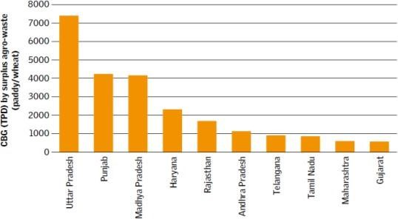

Fig.1. CBG generation potential by agro- residue
- Bio-CNG Production Efficiency Of Various Feedstock’s
The efficiency of biogas production from different feed stocks depends on the substrate characteristics and process conditions. Table below highlights the CBG production potential of different feed stocks.

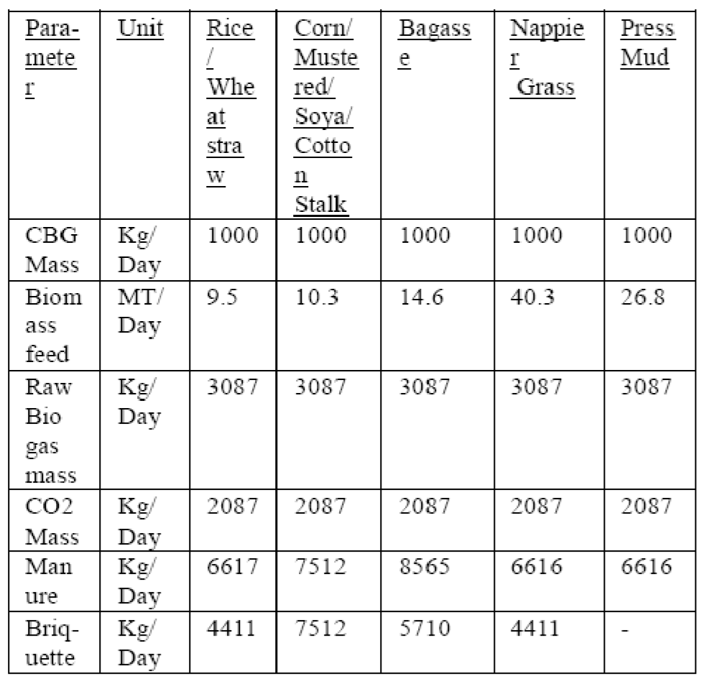
Table 2: Matrix of approximate biogas yields from various feed stocks

METHODS OF BIOGAS

EXTRACTION
Biogas can be extracted through several methods, each with its unique process and efficiency. The primary methods include:
- Anaerobic Digestion (AD)
Anaerobic digestion is the most widely used method for biogas production. It is a biological process where microorganisms break down organic matter in the absence of oxygen, producing methane-rich biogas. The process occurs in four stages: hydrolysis, abiogenesis, gametogenesis, and methanogens. Various digester technologies such as continuous stirred-tank reactors (CSTRs), plug- flow digesters, and up flow anaerobic sludge blanket (UASB) reactors enhance process efficiency.
- Thermochemical Gasification
Gasification is a high-temperature process (700–1000°C) where biomass is converted into syngas, a mixture of carbon monoxide, hydrogen, and methane, in a controlled, low-oxygen environment. This method is more suited for dry biomass feed stocks and requires sophisticated gas- cleaning systems to remove impurities before use.
- Pyrolysis
Pyrolysis is a thermal decomposition process that occurs at 400–800°C in the absence of oxygen. It yields three primary products: biochip, bio-oil, and syngas. While not typically used for biogas production, pyrolysis is an alternative method for converting biomass into energy-dense fuel sources.
- Landfill Gas Recovery
Landfills containing decomposing organic waste naturally produce methane as a byproduct. Methane capture systems installed in landfills can extract and purify this gas for energy use. However, landfill gas recovery is limited in scalability and efficiency compared to anaerobic digestion.
Among these methods, anaerobic digestion remains the most practical and widely adopted for agricultural waste due to its cost-effectiveness, environmental benefits, and scalability.

ANAEROBIC DIGESTION PROCESS
Following pre-processing, the prepared feedstock is transferred to the digester, where microbial consortia, operating under either mesophilic or thermophilic conditions, facilitate the anaerobic digestion process. To minimize the initial lag phase and accelerate microbial adaptation, bio- augmentation is employed by introducing specific microorganisms or enzymatic additives. Both pure cultures and mixed microbial consortia are viable; however, mixed cultures often exhibit synergistic interactions that enhance digestion efficiency. Common inoculants such as cow dung and poultry manure are widely used due to their rich microbial diversity, which promotes higher biogas yields.
Anaerobic digestion (AD) is a biologically complex, multi-stage process that involves four key phases: hydrolysis, acidogenesis, acetogenesis, and methanogenesis. Each phase requires specific environmental conditions to ensure optimal methane production.
- Hydrolysis
Hydrolysis represents the initial step, where complex organic macromolecules—carbohydrates, proteins, and lipids—are broken down into simpler monomers such as sugars, amino acids, and fatty acids. The efficiency of this stage is highly dependent on feedstock composition and pre- treatment techniques. Lignocellulosic materials such as wheat straw and rice husk require mechanical, chemical, or enzymatic pre- treatment to enhance hydrolysis efficiency, as their high lignin content presents a barrier to microbial degradation. The retention time for this phase typically ranges between 3–5 days.
- Acidogenesis
During acidogenesis, hydrolysis products undergo microbial fermentation, yielding volatile fatty acids (VFAs), hydrogen, and carbon dioxide. This stage is dominated by acidogenic bacteria, which thrive in a pH range of 5.2–6.3 under mesophilic conditions (35–40°C). Excessive accumulation of VFAs can cause pH fluctuations, inhibiting subsequent stages of digestion. To maintain process stability, buffering agents such as lime are often introduced.
- Acetogenesis
In this stage, acetogenic bacteria convert volatile fatty acids and hydrogen into acetic acid, carbon dioxide, and additional hydrogen. This transformation is crucial, as acetic acid serves as the primary precursor for methane production in the final stage. The typical retention time for acetogenesis is 5–7 days.
- Methanogenesis
Methanogenesis is the final and most crucial phase, wherein methanogenic archaea metabolize acetic acid and hydrogen to generate methane (CH ) and carbon dioxide (CO ). This step requires optimal pH conditions (6.8–7.5) to sustain microbial activity and maintain process efficiency. Depending on the operational strategy, this phase can be conducted under mesophilic (35–40°C) or thermophilic (50–55°C) conditions. While thermophilic digestion generally results in higher methane yields, it demands greater energy input for temperature maintenance. The retention time for this stage typically ranges between 10–15 days.
The anaerobic digestion process is a dynamic, interdependent system where each phase influences overall biogas yield and stability. Proper control of operational parameters—such as pH, temperature, and microbial population dynamics—ensures efficient substrate conversion and maximized methane production. By optimizing bio- augmentation strategies, pre-treatment methods, and retention times, biogas plants can enhance process efficiency and promote sustainable energy generation.

TYPES OF ANAEROBIC DIGESTION SYSTEMS AND TECHNOLOGICAL

ADVANCEMENTS
Anaerobic digestion (AD) systems are classified based on the method of feedstock introduction into the digester. The three primary types are batch, semi-continuous, and continuous systems, each with distinct operational characteristics and suitability for different feedstock compositions.

- Batch Anaerobic Digestion Systems
Batch digesters operate by filling the reactor to full capacity without any additional feedstock input until the digestion process is complete. These systems are highly resistant to contamination and require minimal preprocessing of feedstock. Batch digestion is suitable for both low-solid content substrates (e.g., manure and sludge) and high-solid content organic waste, such as municipal solid waste. The simplicity of batch systems makes them cost-effective, but the lack of continuous feeding can lead to fluctuations in biogas production.
- Semi-Continuous Anaerobic Digestion Systems
In semi-continuous reactors, feedstock is introduced at regular intervals—typically daily— while an equivalent volume of digestate is removed from the effluent end. This approach balances microbial activity and biogas production, offering a steady and controlled digestion process. These systems can efficiently process a range of feedstocks, from low-solid content materials (e.g., manure) to high-solid content organic waste (e.g., food waste).
- Continuous Anaerobic Digestion Systems
Continuous digestion systems involve a steady inflow of feedstock and an equivalent outflow of digestate, with the flow rate carefully regulated to optimize microbial activity. To ensure smooth operation and prevent mechanical issues, these systems require pumpable, low-solid content substrates free of contaminants. Due to their complexity, continuous reactors necessitate skilled operation and precise feedstock preparation. They are particularly well-suited for processing wastewater sludge from treatment plants, effluents from food processing industries, and diluted manure.
- Advancements in Anaerobic Digestion Technologies
One of the primary challenges in single- stage digesters is managing variations in metabolic properties, nutrient requirements, growth rates, and optimal operating conditions across different stages of digestion. To address this, two-stage digestion systems have been developed, where the hydrolysis and acidogenesis phases are separated from the acetogenesis and methanogenesis stages. This separation enhances methane yield, improves process stability, and reduces retention time. However, the implementation of two-stage systems is often constrained by high capital and operational costs.
In India, technological advancements in anaerobic digestion are driving improvements in biogas yield, process efficiency, and system stability. While traditional digesters remain in use, emerging innovations— such as high-rate digesters, temperature-controlled systems, and integrated biogas upgrading technologies—are gaining widespread adoption. These advancements are instrumental in enhancing the economic viability and scalability of anaerobic digestion as a sustainable bioenergy solution.
- Prevailing Technologies in India
India has largely relied on conventional fixed-dome and floating-drum digesters, commonly used in rural areas for small-scale biogas production. Large-scale plants have adopted up flow Anaerobic Sludge Blanket (UASB) reactors, especially in industrial wastewater treatment. The CSTR (Continuous Stirred Tank Reactor) is gaining traction in commercial setups due to its ability to handle a variety of feedstocks efficiently. Additionally, HighSolid Anaerobic Digestion (HSAD) is being explored for agricultural residue processing. Government programs such as the SATAT (Sustainable Alternative towards Affordable Transportation) initiative are promoting compressed biogas (CBG) plants with biogas upgrading technologies like Pressure Swing Adsorption (PSA) and Membrane Separation.

- Two-Stage Anaerobic Digestion
Two-stage digestion separates hydrolysis and acidogenesis from acetogenesis and methanogenesis, optimizing conditions for each stage. This approach improves volatile solids breakdown, enhances methane yields, and provides greater process stability by reducing the risk of acid accumulation.
- High-Solid Anaerobic Digestion (HSAD)
HSAD is designed for feedstocks with high solid content (>20%), such as agricultural residues and organic municipal waste. This method reduces water consumption, requires smaller reactor volumes, and improves methane production efficiency compared to conventional wet digestion systems.
- Up flow Anaerobic Sludge Blanket (UASB) Reactor
UASB reactors utilize granular sludge to facilitate efficient wastewater treatment and methane production. This technology is widely used in industrial applications where high organic loading rates require efficient solid-liquid separation.
- Anaerobic Membrane Bioreactors (AnMBRs)
AnMBRs integrate membrane filtration with AD, ensuring superior solid-liquid separation, reducing retention time, and enhancing biogas purity. This technology is particularly beneficial for treating high-strength wastewater and improving effluent quality.
- Co-Digestion
Co-digestion involves processing multiple feedstocks simultaneously to balance carbon-to- nitrogen (C/N) ratios, enhance microbial activity, and increase methane production. Agricultural residues can be co-digested with livestock manure or food waste to optimize gas yields.

FACTORS AFFECTING BIOGAS

PRODUCTION
The efficiency and stability of the anaerobic digestion process depend on maintaining specific operational parameters within their optimal ranges. Key factors such as temperature, pH, carbon-to- nitrogen (C:N) ratio, and retention time significantly influence microbial activity and biogas yield. Table 3 outlines the critical process parameters necessary for efficient biogas production. By optimizing these parameters, biogas plants can achieve maximum methane production, enhance process stability, and contribute to the sustainable generation of bioenergy.
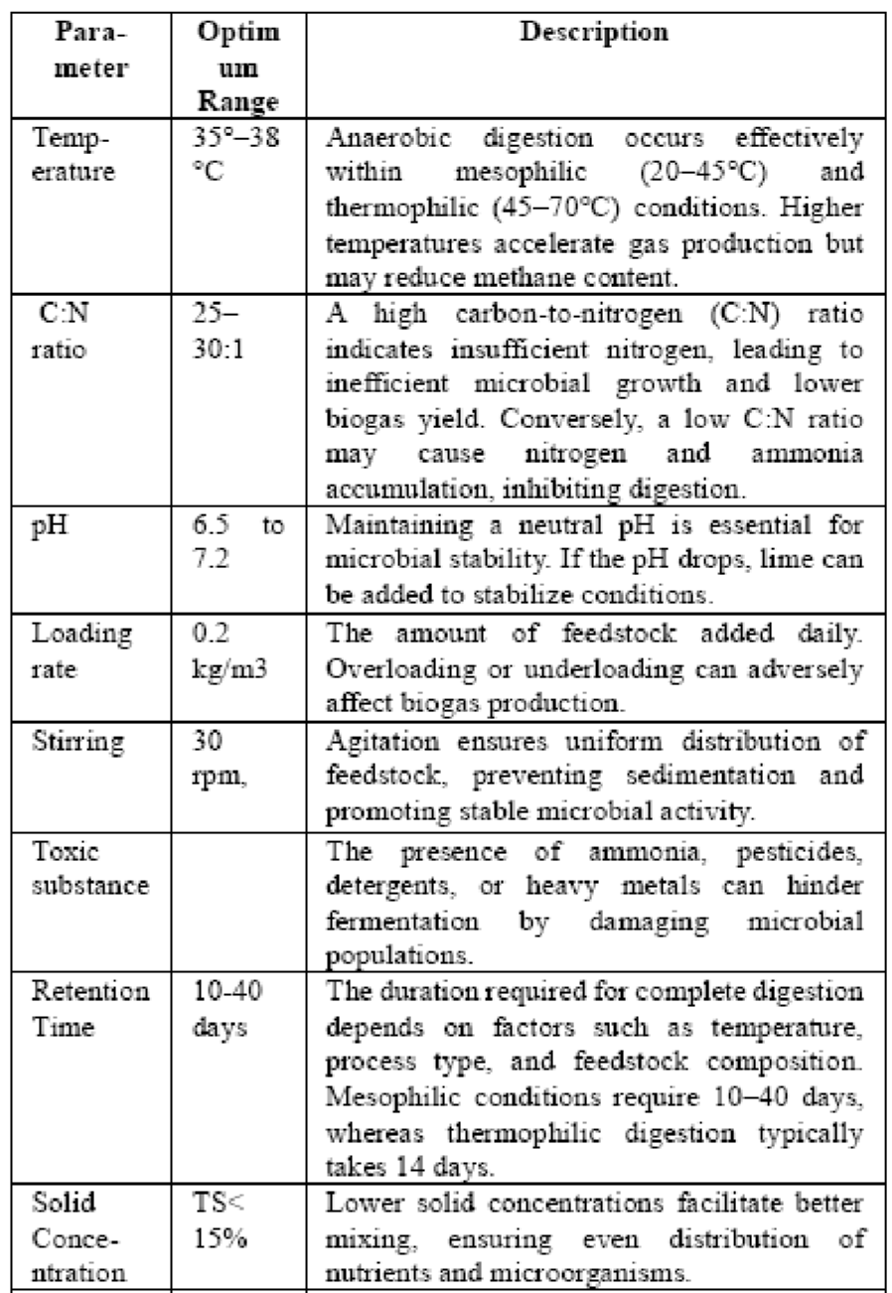
Table 3: Optimal Process Parameters for Biogas Production

BIOGAS CLEANING AND UPGRADING
Biogas contains various unwanted gases that are considered pollutants. The purification process involves two key stages: biogas cleaning and biogas upgrading. In the first stage, harmful substances such as ammonia, hydrogen sulfide, carbon monoxide, and siloxanes are removed. The second stage, known as upgrading, focuses on enhancing the energy value of biogas to meet specific fuel standards. This process includes the separation of carbon dioxide from methane and the removal of moisture to improve the gas quality.
Once biogas undergoes upgrading, it is referred to as biomethane, which consists of over 90% (v/v) methane. Since its composition closely resembles that of natural gas, it is well-suited for applications in the transportation sector and can be injected into gas distribution networks. The following are four widely used methods for biogas upgrading:
- Water scrubbing: Carbon dioxide exhibits greater solubility in water compared to methane, particularly at lower temperatures. In a scrubber column, as biogas comes into contact with water, carbon dioxide dissolves, increasing the methane concentration in the remaining gas phase. Consequently, the gas exiting the scrubber contains a higher proportion of methane.
- Pressure swing adsorption (PSA): Commonly employed in large-scale biogas facilities in India, PSA is a method that separates carbon dioxide by adsorbing it onto a material under high pressure. Typically, activated carbon or zeolites serve as the adsorbents. The process derives its name from the fact that pressure is systematically reduced to regenerate the adsorbing material before the cycle repeats.
- Membrane separation: Specialized membranes, designed to be selectively permeable to specific gases, are used for biogas upgrading. These membranes allow carbon dioxide, ammonia, and water vapor to pass through while restricting the flow of impurities such as hydrogen sulfide and oxygen. The selectivity of these membranes facilitates the efficient separation of carbon dioxide from biogas, yielding an upgraded product with a higher methane concentration. These membranes are commonly structured as hollow fiber bundles to maximize the surface area available for gas separation.
- Chemical scrubbing: In this method, biogas is introduced into a scrubber column, where it interacts with a chemical solvent such as mono ethanol amine (MEA). This solvent reacts with acidic gases like carbon dioxide and hydrogen sulphide, forming a compound that can be easily extracted from the gas stream. Chemical scrubbing with MEA offers advantages such as minimal methane loss, reduced energy consumption, and high methane purity in the final output. However, one drawback of this process is the generation of wastewater containing chemical residues, which requires appropriate treatment and disposal.

COMPRESSION AND DISTRIBUTION
Once purified, biogas is compressed to a pressure of approximately 250 bar, resulting in compressed biogas (CBG), which possesses similar characteristics to compressed natural gas (CNG). The compressed fuel is transferred to a bottling unit, where it is stored in cylinders that are subsequently arranged in cascades for transport and distribution.
CBG is stored at refuelling stations using either a buffer storage system or a cascade storage system. In a buffer system, all reservoir cylinders are maintained at a uniform pressure of 250 bar. Conversely, in a cascade system, storage cylinders are divided into different pressure levels—low, medium, and high. CBG can also be distributed through pipelines at varying pressure levels: low (~40 bar), medium (~160 bar), and high (~250 bar). Alternatively, methane extracted from biogas can be cooled to -162°C, converting it into liquefied biogas (LBG). This form of biogas offers a significantly higher energy density, allowing for more efficient storage. At atmospheric pressure, the energy density of liquid methane is approximately 600 times greater than its gaseous counterpart and
2.5 times greater than methane stored at 250 bar.
The production of biomethane must meet the following standards and requirements:
- It must remain completely free of liquid across all temperature and pressure conditions encountered in storage systems, dispensing units, fuel containers, engines, fuel systems, and pipeline networks.
- It should be devoid of any particulate contaminants, such as dust, dirt, or other impurities.
- The supplied biomethane must be odorized to a level equivalent to that of the local gas distribution system to ensure safety.
- Biomethane intended for automotive use or pipeline distribution must comply with the specifications outlined in the table below.
Characteristic | Requirement | Method of Test, Ref  to
CH4 Content | >90% | IS No. 5130 (Part 3)
Moisture, Content | <5 mg/m3 | IS No. 15641 (Part 2)
Total sulphur (including H2S) | <20 mg/m3 | ISO 6326-3
CO2+ N2+ O2, | <10% (v/v)  <4% (v/v)  <0.5% (v/v) | 15130 (Part 3)
CO2 Content | <10% (v/v)  <4% (v/v)  <0.5% (v/v) | 15130 (Part 3)
O2 Content | <10% (v/v)  <4% (v/v)  <0.5% (v/v) | 15130 (Part 3)
Table 3: Quality Standards for Upgraded Biogas (Biomethane)

INFRASTRUCTURE REQUIREMENTS FOR A 100- TON/DAY BIOGAS PLANT
A 100-ton per day biogas plant requires substantial infrastructure, including:
- Feedstock Pre-Treatment Unit: Shredders, slurry tanks, and mixing equipment to prepare organic waste.
- Digestion Tanks: At least three 5000 m³ digesters for continuous operation.
- Gas Collection and Storage: Floating dome or membrane-based storage systems capable of handling 10,000-15,000 m³ of biogas.
- Upgrading and Compression Unit: For purifying biogas to biomethane quality and compressing it to 200-250 bar for transport.
- Digestate Management System: Solid-liquid separation units and storage tanks for liquid bio- fertilizers.
With an estimated biogas yield of 0.3–0.5 m³ per kg of volatile solids, this facility has the potential to generate over 40,000 m³ of biogas per day. The integration of advanced upgrading and storage technologies enhances the economic viability of the plant, positioning it as a sustainable and scalable solution for bioenergy production.

CONCLUSION
The anaerobic digestion of agricultural feedstock presents a sustainable and economically viable pathway for addressing India’s energy and environmental challenges. The country’s abundant biomass resources, combined with advancements in digestion technologies, create a strong foundation for large-scale biogas adoption. Economic assessments highlight biogas as a competitive alternative to conventional fuels, offering both cost- effectiveness and environmental benefits, including greenhouse gas reduction and efficient waste management.
Despite the notable progress in biogas deployment, several challenges remain, including feedstock logistics, infrastructure constraints, and financial sustainability. Addressing these barriers requires policy interventions, financial incentives, and research-driven innovations. The integration of artificial intelligence (AI), automated process control, and microbial engineering holds great potential for enhancing process efficiency and optimizing methane production.
In conclusion, anaerobic digestion aligns with India’s renewable energy targets, while simultaneously fostering rural development, energy security, and climate change mitigation. With continued investment, technological advancements, and supportive policies, biogas has the potential to emerge as a mainstream renewable energy source, playing a critical role in India’s transition to a low- carbon economy.

REFERENCES
Greening Indian’s Energy Mix With Compressed Biogas (CBG),Centre for Science and Environment, New Delhi ‘Comprehensive Environmental and Social Sustainability Assessment of Bio-CNG as Vehicular Fuel in India’by The Energy and Resources Institute, 2023
Abanades S, Abbaspour H, Ahmadi A et al (2022) A critical review of biogas production and usage with legislations framework across the globe. Int J Environ Sci Technol 19:3377– 3400.
Akbulut A, Arslan O, Arat H, Erbaş O (2021) Important aspects for the planning of biogas energy plants: malatya case study Case Stud Therm Eng 26:101076.
Archana K, Visckram AS, Kumar PS, Manikandan S, Saravanan A, Natrayan L (2024) A review on recent technological breakthroughs in anaerobic digestion of organic biowaste for biogas generation: challenges towards sustainable development goals. Fuel 358:130298.

